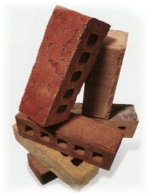
1.What choice would you use to measure the mass of your crayon box?
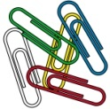
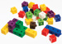
bricks
paper clips
cube-a-links

Why did you choose this unit of measurement?
___________________________________________
2.What is not a good choice to measure the mass of a student classroom desk?
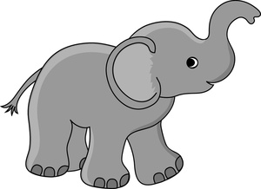


library books
elephant
paper clips

Why is this not a good unit of measurement?
______________________________________________

3. Circle the letter of the picture that shows a good way to compare the mass of these two objects.

Mass = 23 cubes Mass = 36 cubes

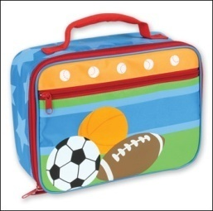
A
B

Mass = 113 paperclips Mass = 36 cubes

What is heavier – the book or the lunch kit?
______________________________________________
How do you know? ________________________________

4. Put the following pictures in order from lightest to heaviest. Use the numbers 1 (lightest), 2, 3, 4 (heaviest).
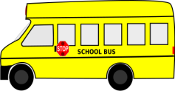
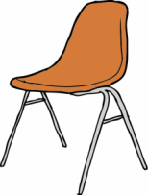

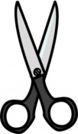

________ ________ ________ _______
Tell why you put them in this order.
______________________________________________

