
Math Activity One Pager Station Sheet

Illuminations: Factor Game

Grade Level : 4 - 6
Topic/Math Concept: Number (factorization)
Outcome(s) N4.3, 4.4; N5.2; N6.2 Demonstrate understanding of factors and multiples (…symbolically);
Materials Required
- Chromebook and internet access
- Link: https://www.nctm.org/Classroom-Resources/Illuminations/Interactives/Factor-Game/

Instructions
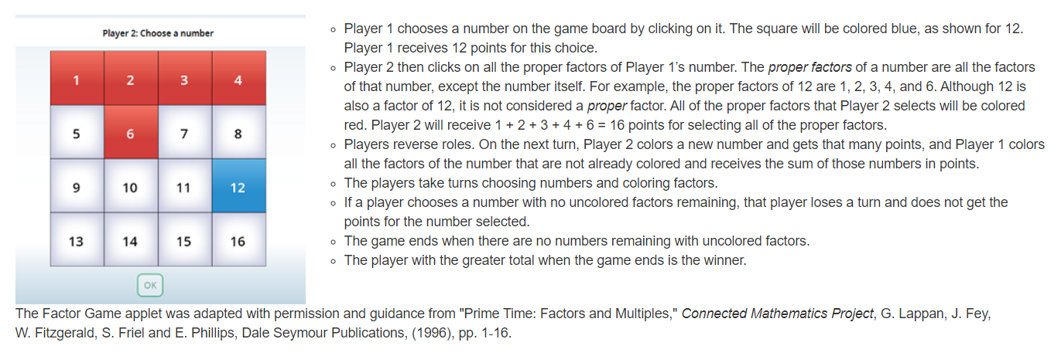

I love it because it can be played with a partner (or against computer), is adjustable (number of rows and columns on the number chart) and it encourages logical thinking and reasoning.
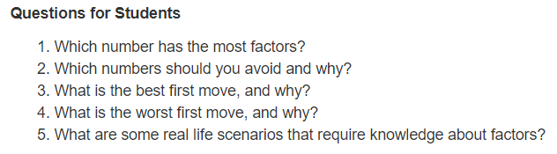
Source: National Council of Teachers of Mathematics (NCTM) Illuminations interactives, https://illuminations.nctm.org/

Contributor and Email: Robin Dubiel, robin.dubiel@cttcs.ca

