Representing Numbers
Count items
Say numbers
*Write numerals correctly
Say numbers on a number path. Cover numbers on a number path and have student say them
Skip count by 2s, 3s, 5s on a number path

Hundreds chart: Look for patterns in hundreds chart
Have student build numbers with base ten blocks and find them on a hundreds chart. Toss a counter onto a number chart and create the number with base ten blocks. Encourage counting by tens.

Use hundreds charts greater than 100 (ex in the 300s, 500s, up to 1000)
Have the student randomly choose a number on the chart and build it with base ten blocks. Encourage counting by hundreds, then tens, then ones.

Count by 10s on hundreds chart starting at random numbers: ex, 8, 18, 28, 38, etc. See the pattern.

Answer one more, one less, two more, two less, ten more, ten less questions. Work to remove the hundreds chart and have the student visualize.
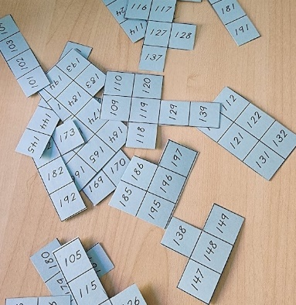
Put together hundreds chart cut out puzzles.

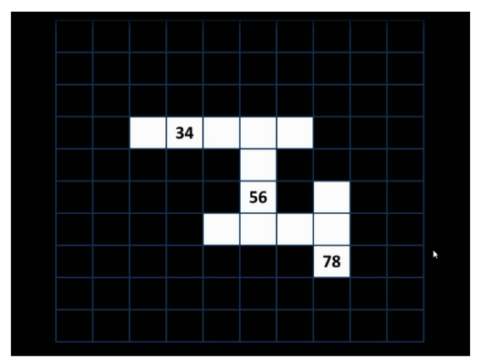
Use Steve Wyborney’s Maze Hundreds Chart to create challenges
https://stevewyborney.com/2016/10/the-maze-hundreds-chart/
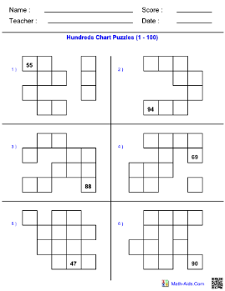
Do hundreds chart puzzles like these
https://teachersherpa.com/template/Hundreds-Chart-Puzzles/3087d02b-d2b4-4a41-9e57-a96f52deca22/details?authorName=Math-Aids

Have student fill in numbers in blank hundreds charts, up to 1000

Have student build, say and write large numbers.

