The game that I have for you today is a place value version of the popular game Yahtzee. I've included the score sheets for four different versions (3-digit numbers, 4-digit numbers, 6-digit numbers, and decimals) so that you can choose the level that works best for your classroom. You could even assign different levels to different students... such easy differentiation!
Materials needed:
- Place Value Yahtzee score sheets (see below)
- Dice (the number of dice needed depends on the game level being used)
  - 3-digit numbers = 3 dice
  - 4-digit numbers = 4 dice
  - 6-digit numbers = 6 dice
  - Decimal numbers = 5 dice
- Cup for holding the dice
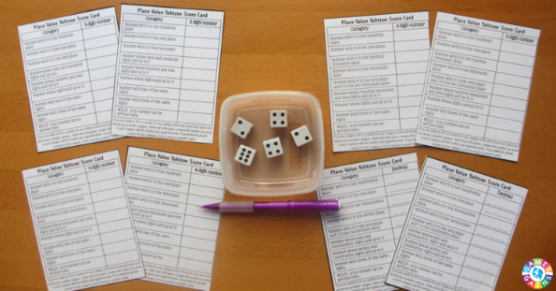
- Pencils

Setting up the game:
Choose the score card that best matches your students!
2. Determine which level you'd like your students to play. Each page in the download is a different level. There are four of the same score sheet on each page.
3. Make enough copies of the score sheets for your students. One score sheet (1/4 page) is needed per player per game.
4. Grab the correct number of dice and some pencils.
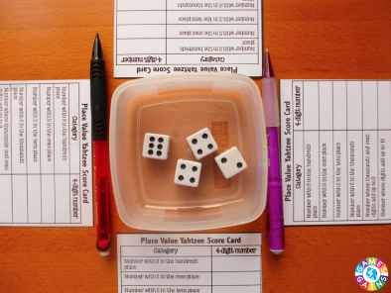
Players are ready to play!
Playing the game:
Object of the game: To score the greatest number of points.
Number of players: 2 or more
1. To decide who goes first, each player rolls all of the dice at once and adds up their roll. The player with the greatest sum goes first.
2. On your turn, you may roll the dice 1 or 2 times. You may stop and score after your first roll or after your second roll. To roll the dice, place all of the dice in the dice cup, shake them, and roll them out onto the table.
3. After your first roll, set any dice aside that you would like to keep ("keepers"). You will not roll any of the "keepers" on your second roll.
- If you decide to keep all of the dice, enter your score on the score sheet. Your turn is now over.
- If you decide to keep some of the dice, put the "keepers" aside and roll the other dice again.
- If you decide to keep none of the dice, place them all back in the cup and roll again.
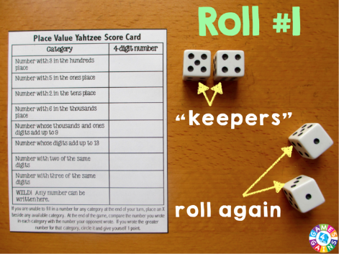
4. For your second roll, re-roll any of the dice you would like.

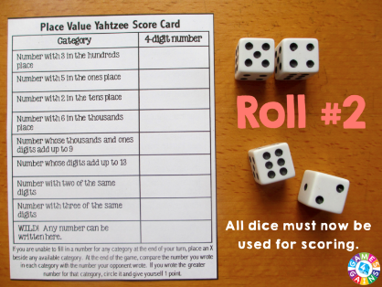
5. After your second roll, you must fill in your score card (see below) with the numbers you have rolled. The next player's turn now begins.
6. Continue taking turns until each player has filled in all 9 category boxes (with either a number or X).
Scoring the game:
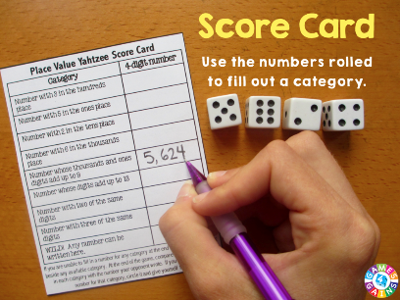
1. After completing your roll, use the numbers showing on the dice to fill in one of the 9 categories on your score sheet. For each category, your goal is create the greatest number you can.
2. You must fill in only one category on each turn. You may fill the categories in any order. If you cannot enter a number for any category after rolling, you must place an X beside any open category. Each category may only be filled in once (with a number or X). Once you have filled in a category, you may not change it during the game.
Determining the winner:
1. After each player has filled in all 9 categories on his/her score sheet with a number or X, it is time for the players to compare their score sheets.
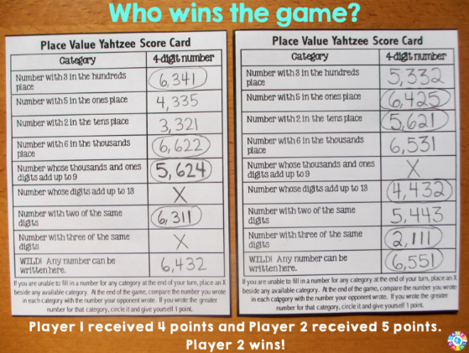
2. Players start by comparing the number they filled in for the first category. An X in any category counts as 0. The player with the greatest number written circles that category on his/her score sheet and receives 1 point. If there is a tie, both players receive the point.
- I like to make students read their number aloud correctly. If they do not read it correctly, they cannot receive the point, even if their number is the greatest.
3. Players repeat the same for all 9 categories.
4. The player with the greatest number of points is the winner! If there is a tie, the players can have one final roll to see who rolls the largest number.

