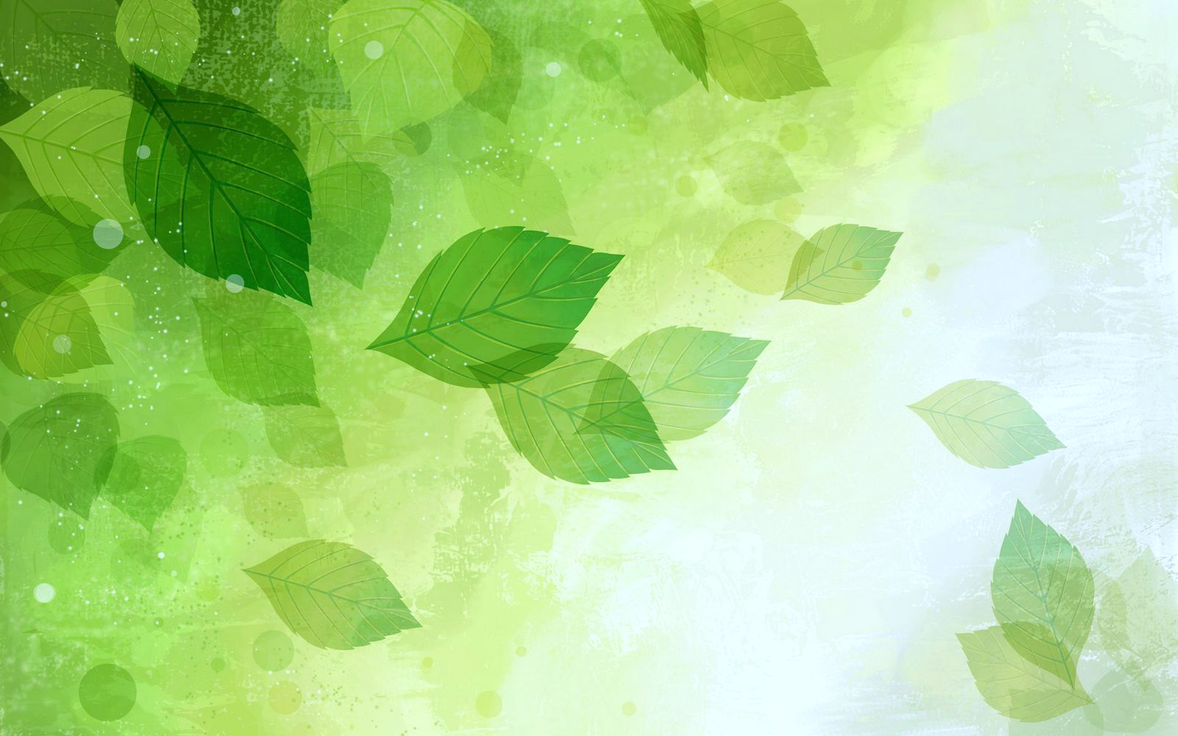
“The way a human being learns has nothing to do with being kept quiet.”
Ralph Peterson
This Photo by Unknown Author is licensed under CC BY

