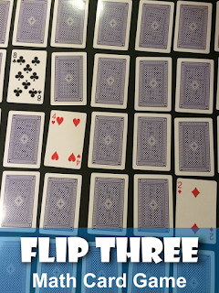

Math Activity One Pager Station Sheet

Flip Three Math Card Game
Topic/Math Concept
Addition/Subtration

Outcome(s) N 2.2

This is a memory style card game with a twist. Players make equations from the three cards that they flip over.

2-4 players

The cards are all placed in rows face down.

Players take turns to flip over three cards and attempt to make an equation using the three cards. The equation can be an addition, subtraction, multiplication or division, e.g. 3+3=6, 8-5=3, 2x1=2, 10÷2=5.

If the player can make an equation they keep the cards. If they can’t make an equation the cards are flipped back over in the same place.
Continue playing until only 7 cards remain. The winner is the player who has the most cards.

http://whoswhoandnew.blogspot.ca/2015/06/dealing-up-some-fun-in-math.html
Contributor and email: ardis.wayman@cttcs.ca

