To Accompany the FP10.3 Pre and Post-Assessment
Measurement (Chapter 1)
AREA
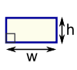
Rectangle
Area = w × h
w = width
h = height
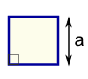
Square
Area = a²
a = length of side
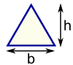
Triangle
Area = ½ × b × h
b = base
h = vertical height

Parallelogram
Area = b × h
b = base
h = vertical height
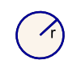
Circle
Area = πr²
Circumference = 2πr
r = radius
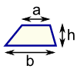
Trapezoid
Area = ½(a+b) × h
h = vertical height
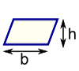

SURFACE AREA and VOLUME
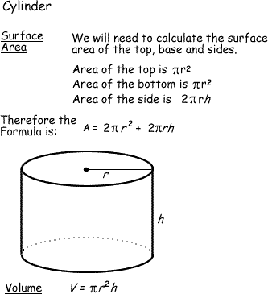
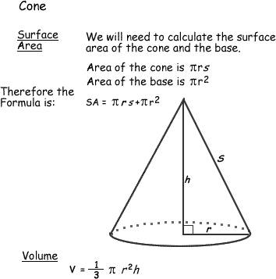
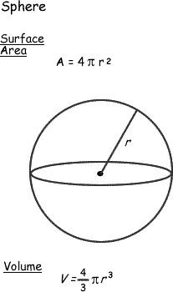
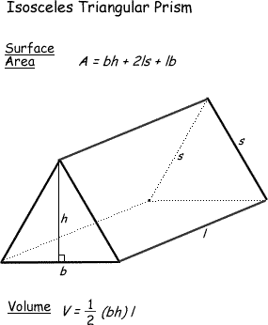
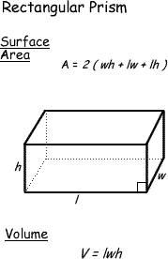
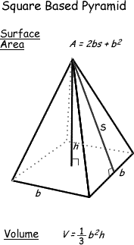

LAND AREA

1 mile² | 640 acres | 1 section

LENGTH

Metric (SI) |  | Imperial
1 millimetre (mm) |  | 0.03937 in
1 centimetre (cm) | 10 mm | 0.3937 in
1 metre (m) | 100 cm | 1.0936 yd
1 kilometre (km) | 1000 m | 0.6214 mile
Imperial |  | Metric (SI)
1 inch (in) |  | 2.54 cm
1 foot (ft) | 12 in | 0.3048 m
1 yard (yd) | 3 ft | 0.9144 m
1 mile | 1760 yd | 1.6093 km

Pythagorean Theorem

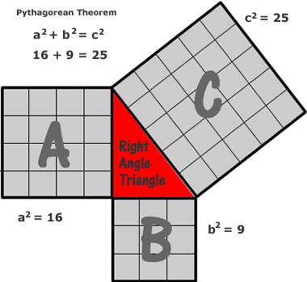

c = hypotenuse
b
a

