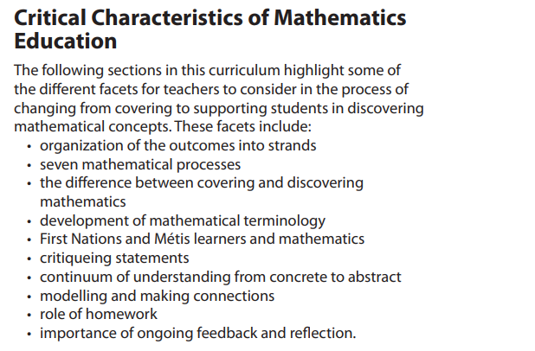

Formative Assessments that include specific non-graded feedback
Effect size = 0.75
Explicitly teaching generative Vocabulary
CRA Continuum https://christtheteacher.ca/ctt/cttcsmathhub/cttcs-math-pathway/
See Saskmath.ca
Providing students with opportunity to construct meaning, find patterns and relationships, rather than teaching “rules” a nd “procedure”
Communication, Making Connections, Visualizing, Representing, Reasoning and Proof, and using Technology

