More or Less

To start the round: One player will roll two dice 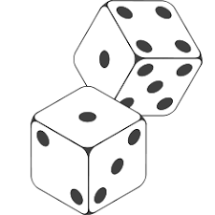

Place the large number in the first box (TENS) and the small number second box (ONES). Set this in the middle where everyone can see. You may like to use a dry erase board to write the number.

This is the two-digit number all players will use:

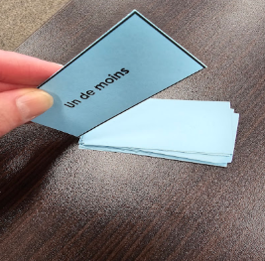

Each player will draw a card from the set and use it to find the number you add to their score. Repeat this until your time is up. Take turns being the player to roll the dice each round.


Keep Score on a piece of paper with your name on it. Show your addition work. Hand it in

Games by Cindy
Score sheet
Name_____________

Score sheet
Name_____________

Score sheet
Name_____________

