Outcome SS2.4 Describe, compare, and construct 2-D shapes, including:
- triangles
- squares
- rectangles
- circles
PRE AND POST-ASSESSMENT
Task 1: Students will identify examples of 2-D shapes as found in personal experiences.
Use these words to identify the 2-D shapes:
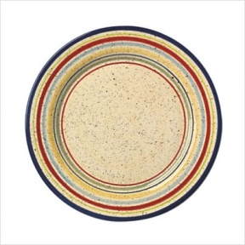
triangle rectangle square circle
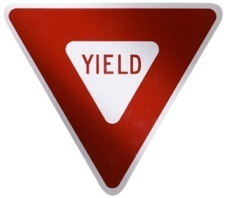

Assess SS2.4a - Is the student able to identify examples of 2-D shapes as found in personal experiences?
Task 2: Have the student compare attributes of 2-D shapes and generalize the descriptions.
Name two attributes of the given 2-D shapes

______________________ ______________________

______________________ ______________________

______________________ ______________________

______________________ ______________________

Which shapes are most similar? __________________________________________________________
Explain your answer: _____________________________________________________________________________________
_____________________________________________________________________________________
Assess SS2.4b - Can the student compare attributes of 2-D shapes and generalize the descriptions?

Mathematics Rubric
Student Name | Date
Outcome SS2.4 Describe, compare, and construct 2-D shapes, including:
- triangles
- squares
- rectangles
- circles.
target
1 | 2 | 3 | 4
Limited progress  Yet to show basic understanding, yet to show beginning performance | Progressing to the standard  Basic understanding, beginning performance | Meeting the Standards  Solid understanding, skilled performance | Advanced application  Advanced understanding, application of learning to new situations
 |  | SS2.4 a, b | SS2.4a,b
The student has difficulty:  - identifying examples of 2-D shapes as found in personal experiences  - comparing attributes of 2-D shapes and generalize the descriptions | The student can  - identify 1 or 2 examples of 2-D shapes as found in personal experiences  - compare the attributes of 1 or 2 2-D shapes and attempt to generalize the descriptions | The student can:  - identify 3 or 4 examples of 2-D shapes as found in personal experiences  - compare attributes of 3 or 4 2-D shapes and generalize the descriptions | The student can:  - identify all 4 examples of 2-D shapes as found in personal experiences  - compare attributes all 2-D shapes and generalize the descriptions with detail
With help I can:  - identify examples of 2-D shapes as found in personal experiences  - compare attributes of 2-D shapes and generalize the descriptions | I sometimes can:  - Identify examples of 2-D shapes as found in personal experiences  - compare attributes of 2-D shapes and generalize the descriptions | I can usually:  - identify examples of 2-D shapes as found in personal experiences  - compare attributes of 2-D shapes and generalize the descriptions | I can always:  - identify examples of 2-D shapes as found in personal experiences  - compare attributes of 2-D shapes and generalize the descriptions

