
Math Activity One Pager Station Sheet

Prime Climb
(Title of the Activity/Game)

Grade Level Grade 4 - 10
Topic/Math Concept Operations, multiplication, factors and multiples, prime numbers

Outcome(s) Many, but especially N 6.2 Factors and Multiples, and N 7.1 Divisibility Rules

Materials Required
Commercially purchased game

Instructions
Instructions in game. In general, each player has 2 tokens, and rolls two 10-sided dice, and they can either add or multiply each of the rolls to/by a circle they are already on. The colour coded number patterns on this game board are part of factor theme work developed by Mathforlove.com.

I love this because: Factors and Multiples is a foundational skill that is often not emphasized enough. Kids without fluency with factors and multiples struggle in higher maths, algebra, and calculus. The game is fun and engaging.

Source Mathforlove.com You can order Primeclimb from Amazon $67.23 CDN

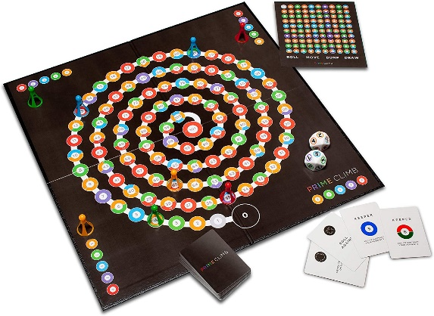

Contributor and Email Cindy Smith Smitc01@cttcs.ca

