- Use some or all of the given shapes to create a clown picture like the one shown. Glue your clown picture beside the given picture.
Name:

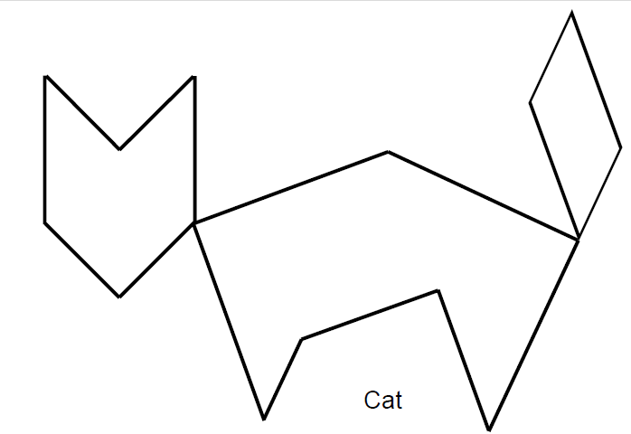
- Use tangram pieces to create this cat. Trace your tangram pieces to show how you created the cat.

