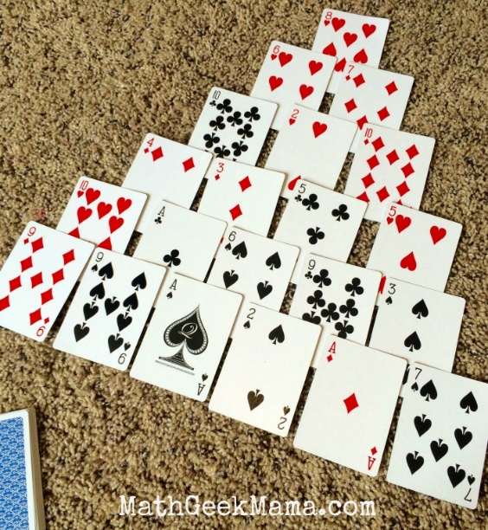

Math Activity One Pager Station Sheet

Pyramid Math Card Game
Topic/Math Concept
Addition/Subtration Level: N2.2
Pyramid: A Math Card Game to Make Ten
The card game Pyramid, helps reinforce addition skills, and learning the number bonds of ten. I think knowing how to “make ten” is an especially important skill for early learners, because it is a helpful strategy to use when adding larger numbers, estimating, counting change and more.

To Set Up Pyramid:
Pyramid is a solitaire style game, but can be played by more than one player by keeping score in each “round.” First, remove all face cards (except Ace, which will represent the number one) and jokers from your deck of cards and shuffle well. Then arrange your cards into a Pyramid with 6 rows, as shown, with each row slightly overlapping the previous row. Place remaining cards in a deck, face down, off to the side.
The goal is to remove cards in the pyramid by “making ten” with two cards. (Or removing a ten card, as it is already equal to ten). However, you can only remove cards that are completely uncovered. Therefore, at the start of the game, you can only use the bottom row of the pyramid to make ten.So for example, in the game shown above, I was able to remove a nine and an ace to make ten.
If no two cards remaining can make ten, the game is not over! Remember the deck of cards off to the side? These can be drawn from to try and find a needed card. So when there is no other option in your pyramid, draw a card from the deck. Continue to draw until you can make another ten. Remove those cards, and continue to play in the same way. If you make it through the entire deck, you can flip them over and begin drawing again.
The game is over when you can no longer remove cards from your pyramid.

To Win the Game:
Once you are stuck and can no longer remove any more cards, add all the remaining cards to determine your score. The person with the smallest number wins!
Source: https://mathgeekmama.com/pyramid-fun-and-easy-math-card-game/
Contributor email : ardis.wayman@cttcs.ca

