More or Less

Roll Two Dice 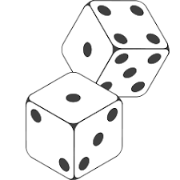

Place the large number in the first box (TENS) and the small number second box (ONES)

This is your two-digit number:

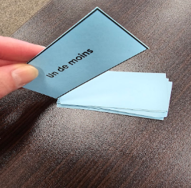

Draw a card from the set and use it to find the number you add to your score.

Keep Score on a piece of paper with your name on it. Show your addition work. Hand it in


Score sheet Name____________________________

