Learning Trajectories
https://www.learningtrajectories.org/math/learning-trajectories

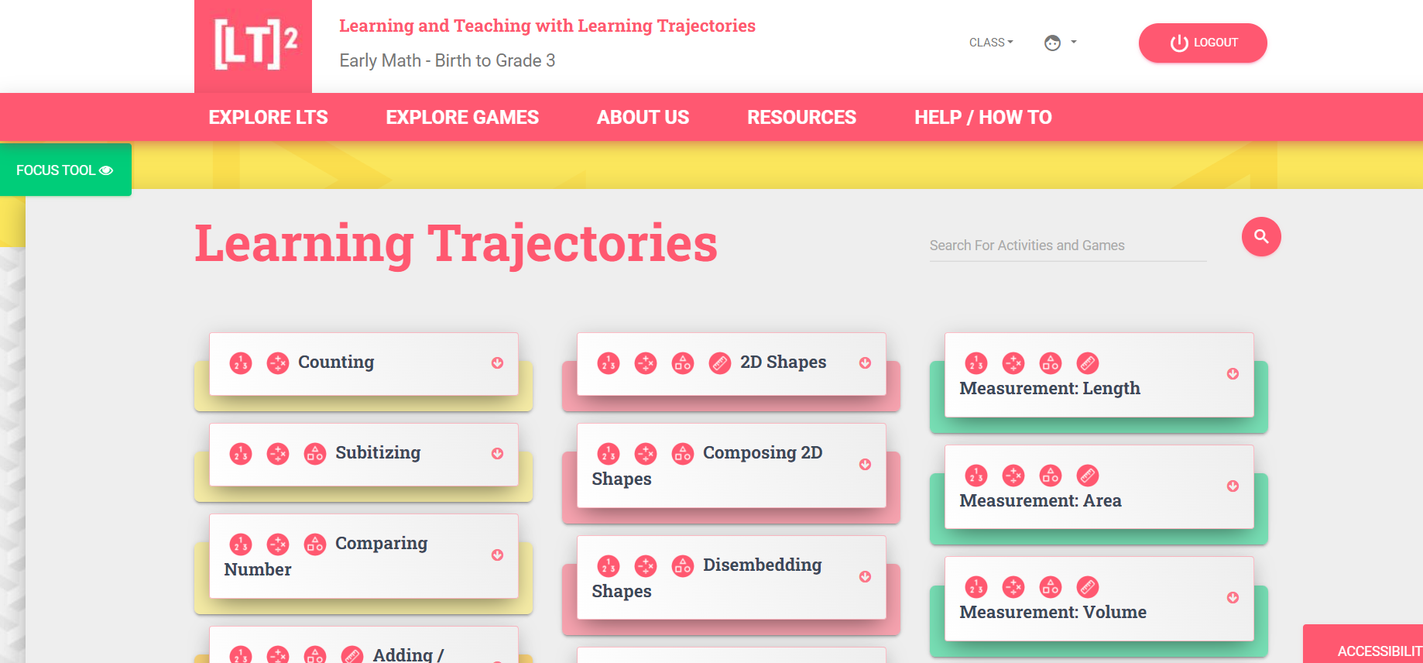

Interventionists will find this web site extremely useful. Note that it focuses on birth to 3rd grade, and on the development of basic numeracy and shape/space concepts.

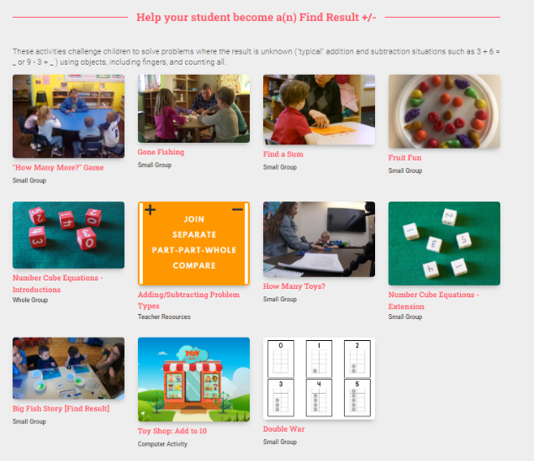
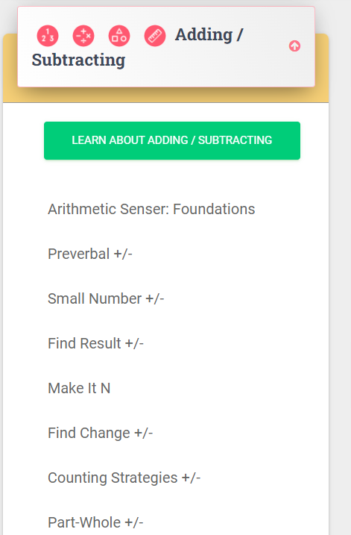
Within each tile pictured above is a drop down menu of learner descriptions. This guide describes where the learner is along the developmental trajectory, what you can expect to see, and how to advance their learning. There are links to activities and games to support development in each area, and videos of how teachers or interventionists might deliver meaningful learning.

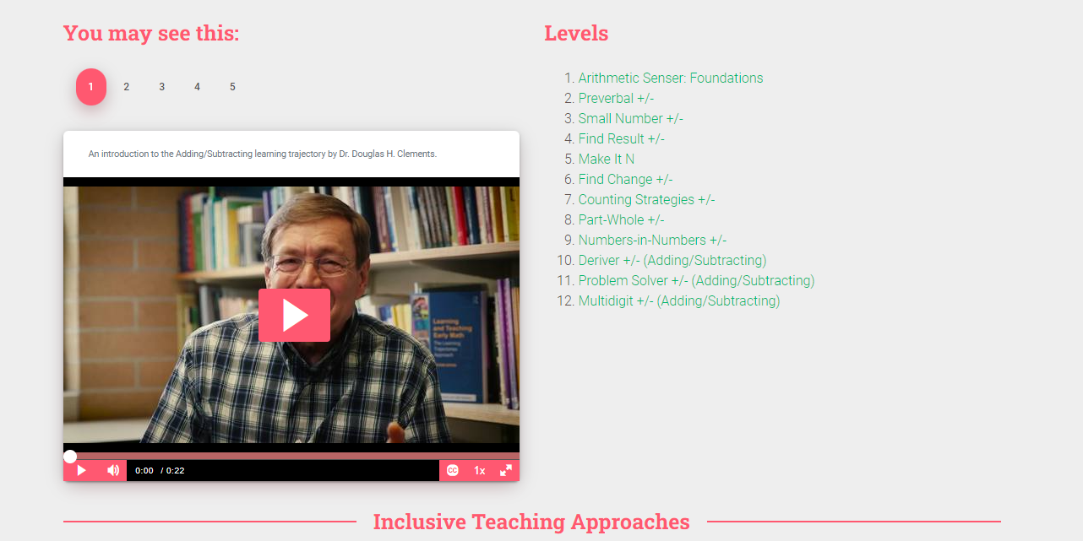
In this tab are videos where Douglas Clements explains how each concept is developed, and videos of students displaying each level of the learning trajectory. There are T

This is the most in-depth resource I have ever seen for the cognitive process of developing number sense. It has very specific details for the teacher/interventionist on how to recognize the learner’s conceptual level and how to teach to advance understanding.

Numeracy Consultants Website: https://numeracyconsultants.net/
Some images of this website:
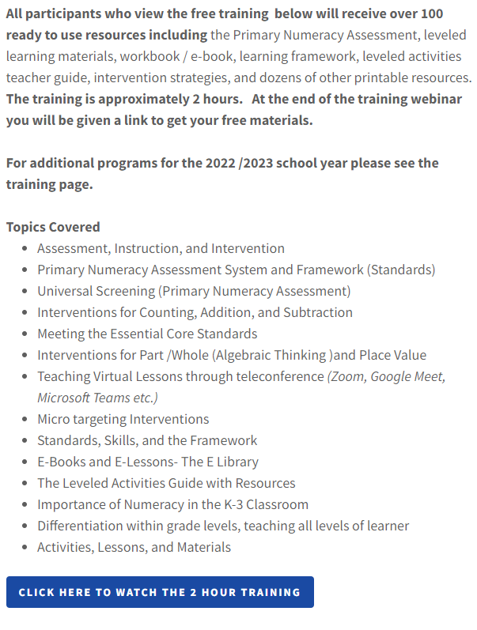
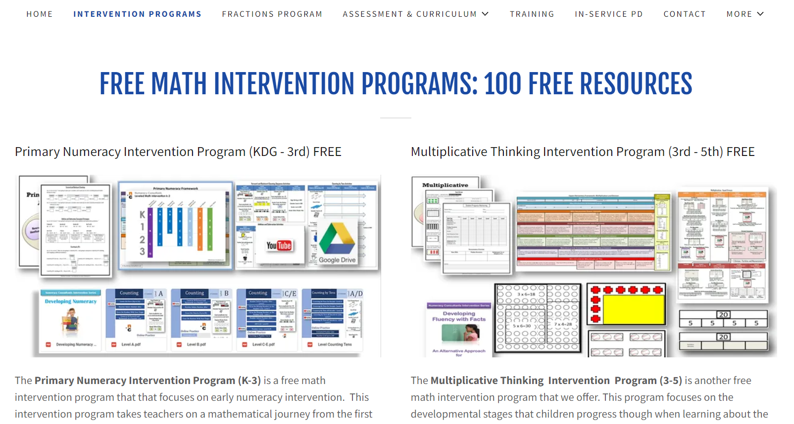
Note the free (level 2) courses that include resources.

