Outcome SS2.5 Demonstrate understanding of the relationship between 2-D shapes and 3-D objects.
Task 1: Have the student describe the faces of a personally relevant 3-D objects by comparing the faces to a 2-D shape.
- Look at the pictures and match the 2-D shape that would best describe it.



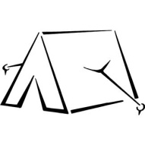



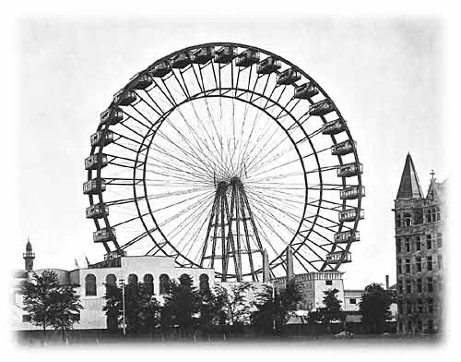

- Create your own 3-D picture. Draw the 2-D shape that would best describe it.

___________________________________ ___________________________________
Picture 2D shape
Assess SS2.5c: Can the student describe the faces of a personally relevant 3-D by comparing the faces to a 2-D shape?
Task 2: Provide students with concrete 3-D objects to use for reference. Ask the student to identify the 3-D objects based on provided descriptions of their 2-D faces.
Assess SS2.5d – Is the student able to identify a 3-D object based on a description of its 2-D faces?

Mathematics Rubric
Student Name | Date
Outcome SS2.5 Demonstrate understanding of the relationship between 2-D shapes and 3-D objects.
target
1 | 2 | 3 | 4
Limited progress  Yet to show basic understanding, yet to show beginning performance | Progressing to the standard  Basic understanding, beginning performance | Meeting the Standards  Solid understanding, skilled performance | Advanced application  Advanced understanding, application of learning to new situations
 |  | SS2.5c,d | SS2.5c,d
The student has difficulty:  -describing the faces of a personally relevant 3-D by comparing the faces to a 2-D shape.  -identify one 3-D object based on descriptions of its faces | The student can:  -describe 1 or 2 of the faces of a personally relevant 3-D by comparing the faces to a 2-D shape.  -identify two 3-D objects based on descriptions of their faces | The student can :  -describe 3 or 4 of the faces of a personally relevant 3-D by comparing the faces to a 2-D shape.  -identify three or four 3-D objects based on descriptions of their faces | The student can:  -describe and draw the faces of a personally relevant 3-D by comparing the faces to a 2-D shape.  -identify all five 3-D objects based on descriptions of their faces
With help I can see that the faces of a 3-D object are 2-D shapes. With help I can identify a 3-D object from a description of it faces. | I can sometimes see that the faces of a 3-D object are 2-D shapes. I can sometimes identify a 3-D object from a description of it faces. | I can usually see that the faces of a 3-D object are 2-D shapes. I can usually identify a 3-D object from a description of it faces. | I can always see that the faces of a 3-D object are 2-D shapes. I can always identify a 3-D object from a description of it faces.

